**Introduction**

The intent of this paper is to forecast the price of Western Canada Select (WCS), a pricing benchmark for Canadian heavy crude oil. The data was collected from a multitude of sources; Statistics Canada, National Energy Board, Energy Information Administration, and the Federal Reserve Bank of St. Louis. The data is monthly and ranges from January 2009 to July 2018.

Crude oil, a naturally occurring fossil fuel, is an essential part of the global energy market and is consumed daily worldwide; it is typically refined into more practical commodities – most commonly in the form of petroleum, gasoline, and diesel. As one of its main products and exports, crude is an integral source of income for Alberta’s economy. In order to measure its price and keep its competitiveness with US oil, WCS was created as a benchmark for heavy Canadian crude.

**Methodology**

This paper will utilize dynamic regression model (DRM) techniques to forecast WCS prices. Modelling the price of WCS requires consideration of several key factors. Even though WCS has been a benchmark for Canadian crude since 2004, many still price WCS as a differential to WTI – the benchmark for US crude – as well as Mexican MAYA – the global benchmark for crude. This is often attributed to the fact that, because of Alberta’s landlocked nature, 99% of Canadian crude exports go to the US. As such, the pricing of WCS depends heavily on these international price criterions. Another component important to modelling WCS is the strength of the economy relative to its trade partners. Because Canada practically exports exclusively to the US, the exchange rate between the two can be used as a proxy variable for economy strength. Economically, it is important to consider demand for a good when modelling its price. To model the demand for Canadian crude, proxy variables will once again be used. A large bulk of the crude the US imports from Canada are sent to PADDs II and III for refinery; as such, the utilization of refinery operational capacity of these two PADDs will be taken into account for the model.

To begin constructing a DRM for WCS prices, we first require all variables to be stationary.

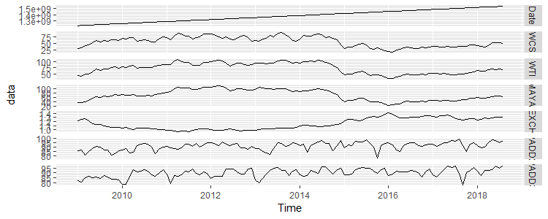

Figure 1. A plot of all variables over time.

As observed in Figure 1, most of the variables have a moving average; they are non-stationary. A first difference is applied to all the data:

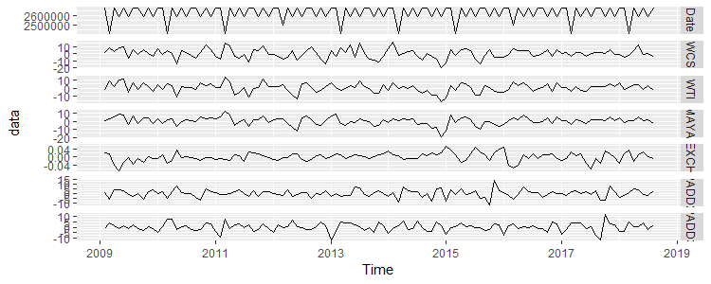

Figure 2. A plot of all the differenced variables over time.

An augmented Dickey Fuller (ADF) test is taken for all the variables, where the null hypothesis is that there is a unit root present in the data – meaning non-stationarity. All the p-values are extremely small; we reject the null hypothesis and conclude that the data does not exhibit non-stationarity.

|  |  |
| --- | --- |
| Variable | P value |
|
| WCS | 5.12E-14 |
| WTI | 1.39E-12 |
| MAYA | 1.62E-10 |
| EXCH | 1.48E-11 |
| PADDII | 2.20E-16 |
| PADDIII | 2.20E-16 |

Table 1. The p values of the ADF of each variable.

F

**Discussion**

**Conclusion**

**Appendix**

**References**

* **Data sources**
  + <https://economicdashboard.alberta.ca/OilPrice>
  + <https://www.eia.gov/dnav/pet/hist/LeafHandler.ashx?n=PET&s=MCRIMUSCA1&f=M>
  + Statistics Canada. Table 25-10-0056-01 Canadian pipeline transport of oil and other liquid petroleum products, monthly (cubic metres)
    - <https://www150.statcan.gc.ca/t1/tbl1/en/tv.action?pid=2510005601>
  + <http://www.aopl.org/resources/pipeline-basics/about-pipelines/>
  + <https://www.neb-one.gc.ca/nrg/sttstc/crdlndptrlmprdct/stt/cndncrdlxprtsrl-eng.html>
  + <https://fred.stlouisfed.org/series/EXCAUS>
  + <https://www.eia.gov/dnav/pet/hist/LeafHandler.ashx?n=PET&s=MOPUEP22&f=M>
  + <https://www.eia.gov/dnav/pet/hist/LeafHandler.ashx?n=PET&s=MOPUEP32&f=M>
* **Other**